Exercise 2: E-commerce Platform Search Function
Scenario:
You are working on the search functionality of an e-commerce platform. The search needs to be optimized for fast performance.

Java code
import java.util.Arrays;
import java.util.Comparator;

class Product {
int productId;
String productName;
String category;

Product(int productId, String productName, String category) {
this.productId = productId;
this.productName = productName;
this.category = category;
}

@Override
public String toString() {
return "Product ID: " + productId +
", Product Name: " + productName +
", Category: " + category;
}
}
public class Exercise_2 {
public static Product linearSearch(Product[] products, int targetId) {
for (Product product : products) {
if (product.productId == targetId) {
return product;
}
}
return null;
}
public static Product binarySearch(Product[] products, int targetId) {
int left = 0;
int right = products.length - 1;

while (left <= right) {
int mid = left + (right - left) / 2;

if (products[mid].productId == targetId) {
return products[mid];
} else if (products[mid].productId < targetId) {
left = mid + 1;
} else {
right = mid - 1;
}
}

return null;
}

public static void main(String[] args) {

Product[] products = {
new Product(105, "Laptop", "Electronics"),
new Product(101, "Mouse", "Electronics"),
new Product(104, "Shoes", "Fashion"),
new Product(102, "Book", "Education"),
new Product(103, "Phone", "Electronics")
};

int searchId = 103;

// Linear Search
Product result1 = linearSearch(products, searchId);

System.out.println("Linear Search Result:");
if (result1 != null) {
System.out.println(result1);
} else {
System.out.println("Product Not Found");
}
Arrays.sort(products, Comparator.comparingInt(p -> p.productId));
Product result2 = binarySearch(products, searchId);
System.out.println("\nBinary Search Result:");
if (result2 != null) {
System.out.println(result2);
} else {
System.out.println("Product Not Found");
}
}
}

OUTPUT:

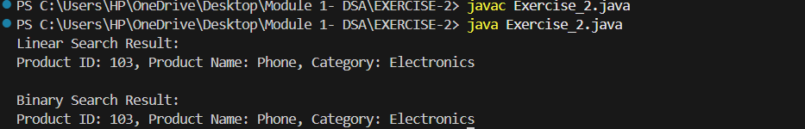

Exercise 7: Financial Forecasting
Scenario:
You are developing a financial forecasting tool that predicts future values based on past data.
Java code
public class Exercise_7{
static double forecast(double value,double rate,int years){
if(years==0){
return value;
}
return forecast(value*(1+rate),rate,years-1);
}

public static void main(String[] args){
double presentValue=10000;
double growthRate=0.10;
int years=5;

double futureValue=forecast(presentValue,growthRate,years);

System.out.println("Present Value: "+presentValue);
System.out.println("Growth Rate: "+(growthRate*100)+"%");
System.out.println("Years: "+years);
System.out.println("Future Value: "+futureValue);
}
}
OUTPUT:

